**React Integration of CRUD Operations**

In continuation to Exp-8

.......................................................................................................................................................

In springboot controller file, add the annotation: @CrossOrigin

------------------------

@RestController

@CrossOrigin

public class AppController {

}

........................................................................................................................................................

Exp9

-------------------------------

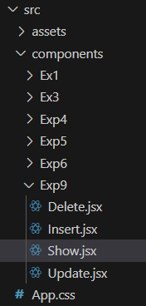

------------------------------------------------------------------------------------------------------

**Insertion operation** :

**Insert.jsx**

import React from 'react'

import axios from 'axios';

export default function Insert() {

    function saveData() {

        var id = document.getElementsByName("idn")[0].value;

        var name = document.getElementsByName("namen")[0].value;

        axios.post("http://localhost:8080/product", {

            "id": parseInt(id),

            "name": name

        })

        .then((res) => {

            alert(res.data);

        });

    }

  return (

    <div>

      ID : <input type="text" name="idn" />

      <br/><br/>

      Name: <input type="text" name="namen" />

      <br/><br/>

      <button onClick={saveData}>SAVE</button>

    </div>

  )

}

**main.jsx**

import Show from './components/Exp9/Insert.jsx'

createRoot(document.getElementById('root')).render(

  <Insert />

)

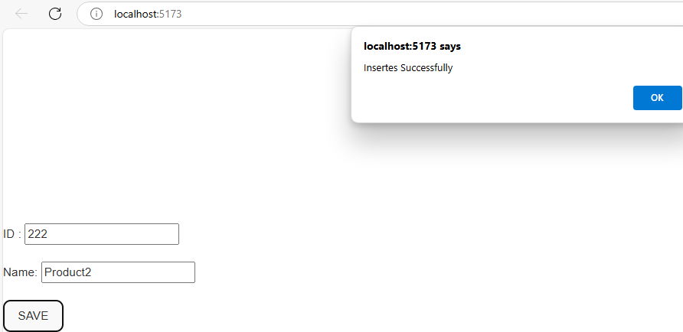

**DELETE Operation:**

**Delete.jsx**

import axios from 'axios';

import React from 'react';

export default function Delete() {

    function deleteData() {

        var id = document.getElementsByName("idn")[0].value;

        axios.delete(`http://localhost:8080/product/${id}`, {})

        .then((res) => {

            alert(res.data);

        });

    }

    return (

        <div>

            ID: <input type="text" name="idn" />

            <br/><br/>

            <button onClick={deleteData}>DELETE</button>

        </div>

    );

}

**main.jsx :**

import Show from './components/Exp9/Delete.jsx'

createRoot(document.getElementById('root')).render(

  <Delete />

)

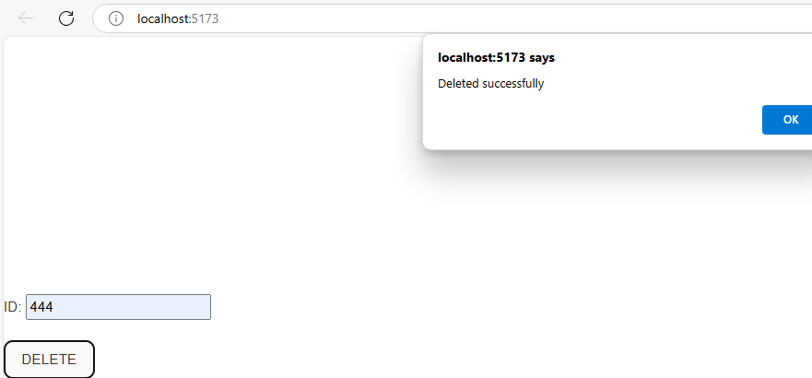

**Updation operation**

**Update.jsx**

import React from 'react'

import axios from 'axios';

export default function Update() {

    function updateData() {

        var id = document.getElementsByName("idn")[0].value;

        var name = document.getElementsByName("namen")[0].value;

        axios.put("http://localhost:8080/product", {

            "id": parseInt(id),

            "name": name

        })

        .then((res) => {

            alert(res.data);

        });

    }

  return (

    <div>

      ID : <input type="text" name="idn" />

      <br/><br/>

      Name: <input type="text" name="namen" />

      <br/><br/>

      <button onClick={updateData}>UPDATE</button>

    </div>

  )

}

**main.jsx :**

import Show from './components/Exp9/Update.jsx'

createRoot(document.getElementById('root')).render(

  <Update />

)

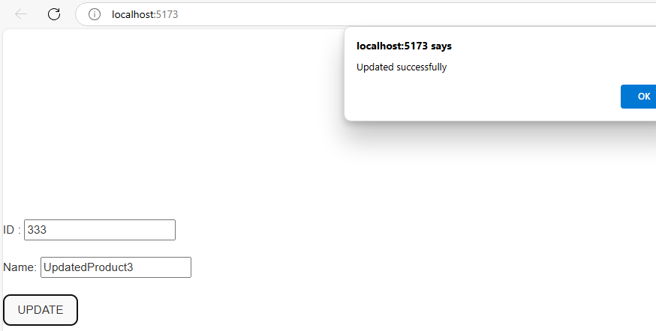

**Retrieval Operaton:**

**Show.jsx**

import React, { useState } from 'react';

import axios from 'axios';

export default function Show()

{

    const [result, setResult] = useState(null);

    if (result == null) {

        axios.get("http://localhost:8080/product", {})

        .then((res) => {

            setResult(res.data);

        });

    }

    if (result == null)

        return (

            <div>

                Data is Fetching

            </div>

        );

    else

        return (

            <table border={1}>

                <tr>

                    <th>ID</th>

                    <th>NAME</th>

                </tr>

                {result.map((element) => {

                    return (

                        <tr key={element.id}>

                            <td>{element.id}</td>

                            <td>{element.name}</td>

                        </tr>

                    );

                })}

            </table>

        );

  }

**main.jsx :**

import Show from './components/Exp9/Show.jsx'

createRoot(document.getElementById('root')).render(

  <Show />

)

